Assignment 9
Name :- Raghav Anil Bhise
PRN :- 22311792
Roll no. :- 391061
Title :- Use appropriate algorithm and perform sentiment analysis for Indian Language
1. Aim
To perform Sentiment Analysis on Indian language text (Marathi) using an appropriate Natural Language Processing algorithm.

2. Objective
- To understand sentiment analysis
- To apply NLP on Indian language
- To use transformer-based model for prediction
- To classify sentences as Positive, Negative, or Neutral

3. Algorithm Used
- Transformer Model
- Multilingual BERT
- HuggingFace Pipeline
- Sentiment classification using star rating conversion
Model used:
nlptown/bert-base-multilingual-uncased-sentiment
This model supports multiple languages including Indian languages.

4. Tools and Technologies Used
- Python
- Jupyter Notebook / Google Colab
- Transformers Library
- Torch
- NLP Pipeline

5. Theory
Sentiment Analysis is a Natural Language Processing (NLP) technique used to determine the emotional tone of a sentence.
It is used to classify text into categories such as:
- Positive
- Negative
- Neutral
In this assignment, sentiment analysis is performed on Marathi language sentences using a Multilingual BERT model.
The model predicts sentiment in the form of star ratings (1–5), which are converted into sentiment labels.
Conversion rule:
Stars | Sentiment
1–2 | Negative
3 | Neutral
4–5 | Positive

6. Program Code
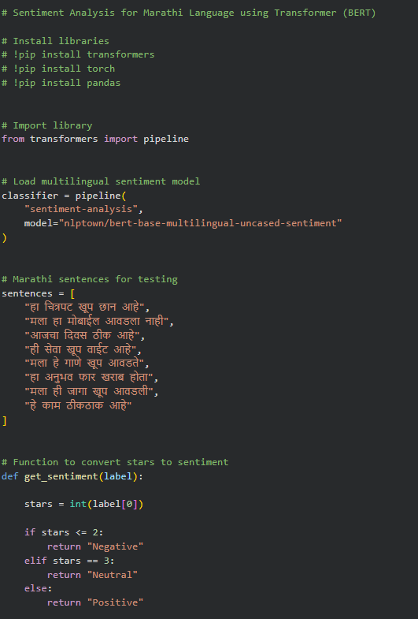
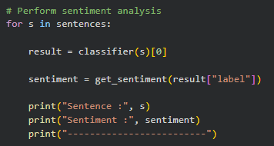
7. Input Sentences
Example Marathi sentences used:
- हा चित्रपट खूप छान आहे
- मला हा मोबाईल आवडला नाही
- आजचा दिवस ठीक आहे
- ही सेवा खूप वाईट आहे
- मला हे गाणे खूप आवडते
- हा अनुभव फार खराब होता
- मला ही जागा खूप आवडली
- हे काम ठीकठाक आहे

8. Output
Output obtained after performing sentiment analysis on Marathi sentences:
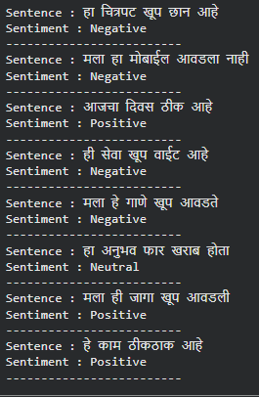

9. Result Analysis
The sentiment analysis was performed on Marathi sentences using a multilingual BERT model.
The model generated sentiment predictions for all input sentences.
Some predictions are correct, while some are incorrect.
Example analysis:
Sentence | Expected | Output
हा चित्रपट खूप छान आहे | Positive | Negative
मला हा मोबाईल आवडला नाही | Negative | Negative
आजचा दिवस ठीक आहे | Neutral / Positive | Positive
ही सेवा खूप वाईट आहे | Negative | Negative
मला हे गाणे खूप आवडते | Positive | Negative
हा अनुभव फार खराब होता | Negative | Neutral
मला ही जागा खूप आवडली | Positive | Positive
हे काम ठीकठाक आहे | Neutral | Positive
Reason for incorrect results:
- The model is trained mainly on English and other foreign languages
- Marathi language support is limited
- Multilingual models may not fully understand regional languages
Even though accuracy is not perfect, the model successfully performed sentiment classification.

10. Conclusion
In this assignment, sentiment analysis was performed on Marathi language text using a multilingual transformer-based model.
The model successfully predicted sentiment for all given sentences as Positive, Negative, or Neutral.
However, some predictions were incorrect because the model is not specifically trained for Marathi language.
This experiment shows that sentiment analysis for Indian languages requires language-specific datasets and models for better accuracy.
Thus, the objective of performing sentiment analysis using an appropriate algorithm was successfully achieved.

